About Hispanic Unity of Florida
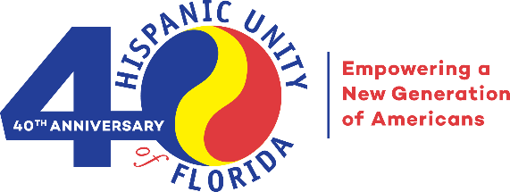
Hispanic Unity of Florida (HUF) was founded in 1982 by community leaders to guide newcomers to the U.S. on their journey to their American dream and to ease the acculturation process. Today, HUF is Broward County’s largest 501(c) (3) dedicated to the immigrant population. With 12 programs and more than 30 services offered in 4 languages, this agency serves South Florida’s diverse community. Since its inception, HUF has served over 500,000 individuals.
We provide services in the following program areas: Education, Economic Development, and Civic Engagement. We also focus on Public Policy & Advocacy. The COVID-19 pandemic changed the way we operate as an agency; currently our programs and services are in-person and virtual.
HUF’s comprehensive approach to advance and accelerate the pace of social and economic stability is family-centered, two generation (2Gen) and operates through a racial equity lens. HUF’s integrated services provide a seamless framework of economic stability that include immediate assistance as well as long-term solutions. Family coaches work within the 2Gen approach, simultaneously tracking outcomes for children and adult family members.

HUF’s mission: Empowering immigrants and others to become self-sufficient, productive, and civically engaged.

We provide the following programs and services:
Education
- Unity 4Kids (U4K) Early Learning Center: 5-Star Rated, Nationally-Accredited Licensed Pre–K & VPK for 3- to 5-Year-olds
- Unity 4Teens(U4T) Program: Year-round After-School & Summer-School Program for Youth ages 11- to 18
- English for Speakers of Other Languages (ESOL)
- Family Strengthening Program: Research-based parent-education program that teaches parents the importance of engaging in nurturing behavior promoting healthy physical and emotional development in children.
Economic Development
- Center for Working Families (CWF): Comprehensive one-stop shop that consists of public benefits assistance, employment services and money management assistance.
- Pathway to Homeownership: Program to learn all the steps necessary to purchase a home, rent a property and foreclosure prevention
- Emerging Entrepreneurs (EE) Program: Workshops in Spanish for Existing & Emerging Small Business Owners
- Volunteer Income Tax Assistance (VITA) Program is a Free Tax Preparation Service
- Health and Public Benefits Income Support
Civic Engagement
- Immigration Services
    - Pathways to Citizenship Program and Naturalization Assistance
    - Free Immigration Consultations through Americans for Immigrant Justice (AIJ)
- Voter Registration and Engagement
- Legal Consultation and Referrals (in partnership with Legal Aid Service of Broward County)
Public Policy & Advocacy
- Two-pronged Public Policy Agenda.
  - Short-term Covid-19 policies such as equitable healthcare access, food insecurity, and financial benefits.
  - Long-term issues which impact our clients and community
Find out more information: Please find more about our programs and services at www.Hispanicunity.org where you can also find our Annual Report and our IRS 990.

